Supply Chain Management — Week 2
Session 3: Product Segmentation, SC Strategy Matching & Push-Pull Framework
Course: Supply Chain Digitization
Recap & Session Flow
- Sessions 1 & 2: SC challenges → need for segmentation → types of segmentation
- Segmentation types: Inventory / Demand / Value chain / Channel / Geographic / Product / Customer
- Important: Never use one segmentation alone — always a combination
- Segmentation → defines roles of SC drivers: Facilities, Transportation, Inventory, Sourcing, Pricing, Information
- This session: Product Segmentation → matching to SC type → Push / Pull strategy
Central Question: What is the Right SC for a Given Product?
- Two things must be understood:
  - Type/Nature of product flowing through the SC
  - Priority / competitive strategy of the SC
- Product type + SC priority → determines SC strategy (efficient or responsive)
- Product segmentation framework used: Functional vs Innovative Products
Product Segmentation: Functional vs Innovative
Functional Products
- Demand: Stable, constant, low uncertainty
- Product Life Cycle: Long
- Lead Time: Longer — focus is on consolidation, coordination, and cost
- Average Stockout Rate: Low — sufficient inventory always maintained
- Product Variety: Low — same products used repeatedly, minimal variation
- Focus: Cost minimization
- Example: Steel — standard product, stable demand, long life cycle
- Example: Everyday household products — stable demand throughout year
Innovative Products
- Demand: Volatile, uncertain, unpredictable
- Product Life Cycle: Short — driven by new technology, new materials, quality improvements
- Lead Time: Short — product must be available as soon as demand arises
- Average Stockout Rate: High — high demand uncertainty = higher risk of stockout
- Product Variety: High — companies must offer more variety to sustain in market
- Focus: Flexibility and responsiveness
- Example: Mobile phones — frequent new models, shrinking time gap between launches, shorter PLC
- Example: Consumer electronics with high technology
★ Functional = long PLC, stable, cost-focused. Innovative = short PLC, volatile, responsiveness-focused.
Quick Comparison: Functional vs Innovative
- Demand: Stable (F) | Volatile / Uncertain (I)
- Life Cycle: Long (F) | Short (I)
- Lead Time: Long (F) | Short (I)
- Stockout Risk: Low (F) | High (I)
- Product Variety: Low (F) | High (I)
- SC Focus: Cost (F) | Flexibility / Responsiveness (I)
- SC Type: Efficient (F) | Responsive (I)
- Strategy: Push (F) | Pull (I)
Matching Product Type to SC Strategy
Functional Product → Efficient SC
- Stable demand → no need for high flexibility
- Production strategy: Forecast-driven
- Lead time: Long (acceptable since demand is predictable)
- Inventory level: Low
- Goal: Make product available at minimum cost
- SC type: Efficient Supply Chain
- Strategy: PUSH
Innovative Product → Responsive SC
- Volatile demand → needs high flexibility
- Production strategy: Demand-driven (not forecast-driven)
- Lead time: Short — customer expects immediate availability
- Inventory level: High
- Goal: Fulfill demand on timely basis, manage uncertainty
- SC type: Responsive Supply Chain
- Strategy: PULL
★ Key match: Functional → Efficient → Push | Innovative → Responsive → Pull
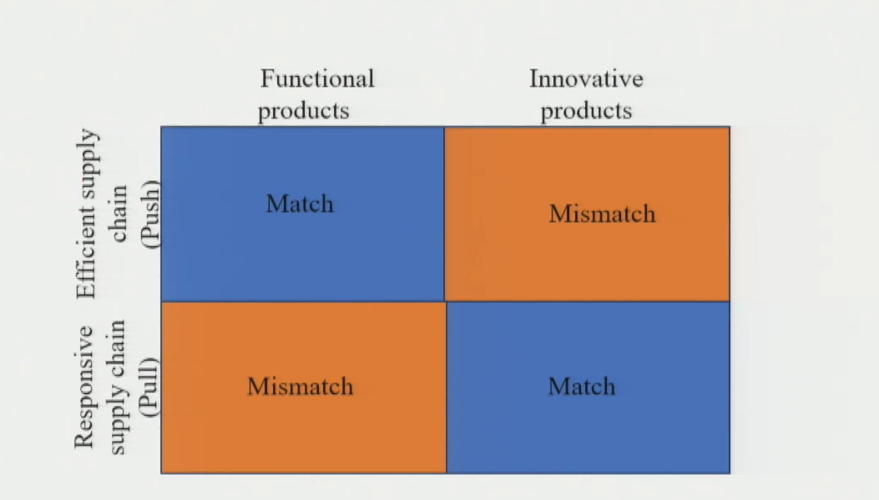
Push Strategy
Definition
- All SC processes are forecast-driven
- Goods are produced and pushed through the SC based on demand predictions
- Flow: Production → Distribution → Retail (all based on forecast)
- It refers to a method of production and distribution where goods are produced and pushed through the supply chain based on forecasts or predictions of demand
Characteristics
- Forecast-driven — decisions based on predicted demand
- High volume / Mass production
- Inventory accumulation — stock is built up in anticipation of demand
- Low customization — standard products
- High initial investment
Challenges
- Limited scope to handle demand variability
- If product not sold → carried for long → inventory obsolescence risk
- Low responsiveness to sudden demand changes
Best Used When
- Demand is stable and predictable
- Product is functional with long life cycle
- Goal is cost efficiency
Pull Strategy
Definition
- All SC functions (production + distribution) are driven by actual customer demand
- Goods are manufactured only after demand is received
- Flow: Customer demand → Production → Distribution (demand triggers everything)
- It is an approach to production and distribution where goods are produced based on actual customer demand
Characteristics
- Demand-driven — decisions triggered by actual orders
- High customization — responds to specific customer needs
- Reduced Inventory
- High responsiveness
- Low obsolescence risk — no excess inventory built up
- Efficient resource utilization
Challenges
- Lead time management — critical and difficult
- Coordination complexity
- Demand is uncertain
- Production availability constraints — capacity may limit response
Best Used When
- Demand is uncertain / volatile
- Product is innovative with short life cycle
- Goal is flexibility and responsiveness

Push-Pull Combination (Hybrid Strategy)
Reality in Practice
- In practice: Pure push or pure pull rarely exists
- Most real SCs use a combination of both strategies
- A Push-Pull Boundary divides the SC into two zones:
  - Zone 1 (upstream): Push — low uncertainty part of SC
  - Zone 2 (downstream): Pull — high uncertainty / customization part
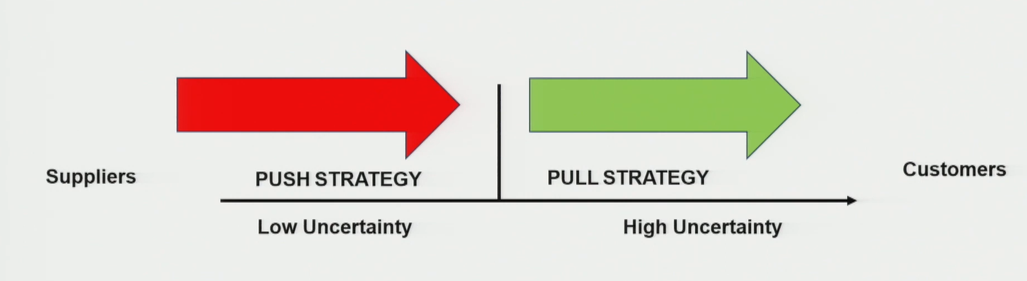
Push-Pull Boundary — Definition
- The point in the SC that separates the push zone from the pull zone
- Can exist between any two players in the SC (Supplier ↔ Mfg ↔ Distributor ↔ Customer)
- Position of boundary depends on: level of customization required
- Boundary closer to customer → less complexity in SC
- Boundary closer to supplier → more customization → higher complexity
Example 1: Vehicle Color Customization
Setup
- Company offers same vehicle type in different colors depending on customer choice
Push Zone: Supplier → Manufacturer → Distributor
- Vehicle type is standard / constant
- Suppliers: know what components are needed → keep raw materials ready
- Manufacturing: demand is forecasted → assembly line runs on push strategy
- Distributor: receives standard vehicle → holds it in one color (basic)
Push-Pull Boundary: At the Distributor
- Customer communicates preferences (color, seat type, accessories) to distributor
- This triggers the pull strategy
Pull Zone: Distributor → Customer
- Distributor customizes vehicle as per customer demand (paints, adds components)
- Delivery made after customization is complete
- No customization done upstream — only at distributor level
★ Takeaway: Standardize upstream (push) → Customize downstream (pull). Boundary = at distributor.
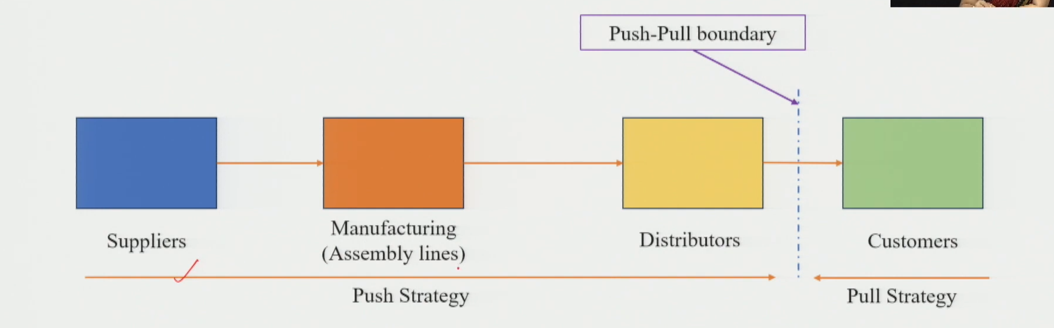
Example 2: Component-Level Customization (Automobiles)
Setup
- Automobile company offers different vehicle variants customized per customer order
- Customization is at the component/raw material level, not just cosmetic
Pull Zone: Suppliers
- Suppliers must deliver specific components as per customer order
- Suppliers follow pull strategy — produce/deliver based on what is required
Push-Pull Boundary: Between Supplier and Manufacturing
Push Zone: Manufacturing → Distributor → Customer
- Once components are received, assembly process is standard
- Manufacturing knows exactly how to assemble → follows push strategy
- Distributor: receives finished vehicle → standard delivery schedule → pushes to customer
- No special requirements at distributor or delivery stage
★ Takeaway: Pull at supplier level (component variability), Push post-manufacturing (standard assembly + delivery). Boundary = between supplier and manufacturing.
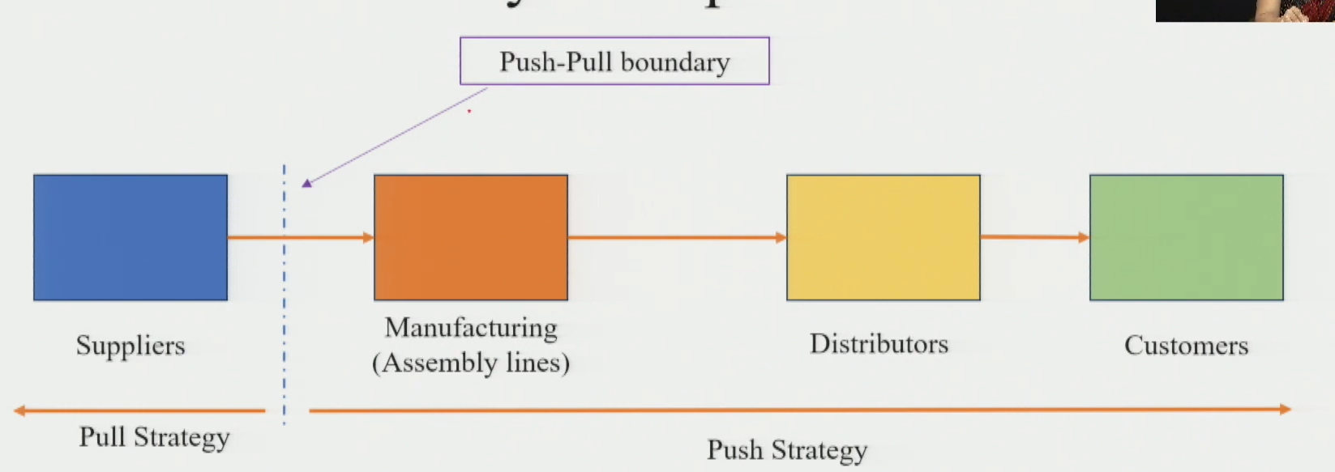
Managing the Push-Pull Boundary
Key Tool: Buffer Inventory
- Carry buffer inventory at the players on either side of the push-pull boundary
- Buffer absorbs demand fluctuations and enables customization without disrupting upstream
Postponement Strategy
- Closely linked to push-pull boundary management
- Postponement = delay customization/differentiation as long as possible in the SC
- Standard product moved upstream via push → customization done at last possible point (pull zone)
- Ensures: flexibility while maintaining cost efficiency upstream
Session Summary — Full Connection
- Product Segmentation: Functional vs Innovative
- SC Type Matching: Functional → Efficient SC | Innovative → Responsive SC
- Strategy Matching: Efficient SC → Push | Responsive SC → Pull
- Reality: Hybrid Push-Pull → separated by a Push-Pull Boundary
- Boundary position: determined by level of customization required
- Tool to manage boundary: Buffer inventory + Postponement strategy
★ Exam tip: Always link product type → SC type → push/pull → boundary location in any answer. This chain is the core framework of this session.
★ Push-Pull boundary can sit between ANY two SC players — position depends on where uncertainty/customization begins.

